FOR IMMEDIATE RELEASE

Basic Needs, Brighter Future Program Helps Children and Youth Develop Healthy Habits in <city>

[<city>, <date>]—Basic Needs, Brighter Future is a national program that provides access to fresh, healthy foods and gives children and youth the skills they need to make informed choices around nutrition.

Offered to children and youth of all ages at Boys and Girls Clubs across the country, the Basic Needs, Brighter Future program:
- Allows for the development and implementation of key nutrition programming including breakfast programs and youth cooking programs
- Encourages children and youth to make healthy choices about the food that they eat
- Provides access to fresh, healthy foods and snacks for children, youth, and families

<Club name> is proud to be running the program for Club members in the <name> community. At our Club, <# of> Basic Needs, Brighter Future program participants are <insert description of the type of programming kids are doing, skills they are acquiring, etc.>.

<optional: testimonial quote from a Basic Needs, Brighter Future participant or staff member>

<quote from Club executive director: example—"Ensuring children have access to healthy food and the knowledge they need to make healthy choices is a priority at Boys and Girls Clubs,” says <name>, <title>, <Club>. “We are proud to launch Basic Needs, Brighter Future to help combat food insecurity and improve the health of children and families in our community.”>

Basic Needs, Brighter Future is generously supported by President’s Choice Children’s Charity.
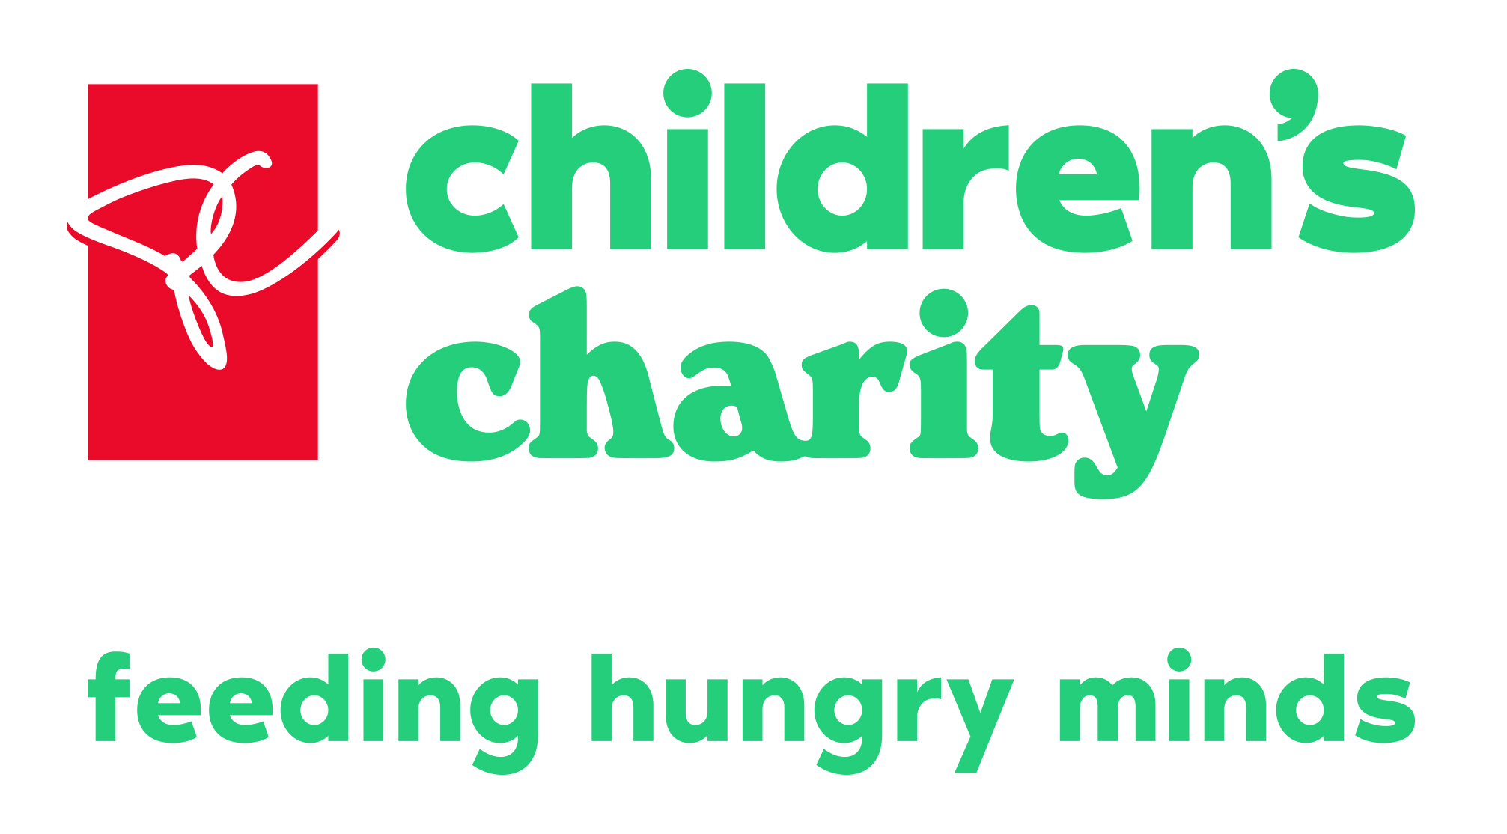

###

About <Club name>
<insert Club boilerplate>

For more information, please contact:
<name>
<title>
<Club>
<phone>
<email>

