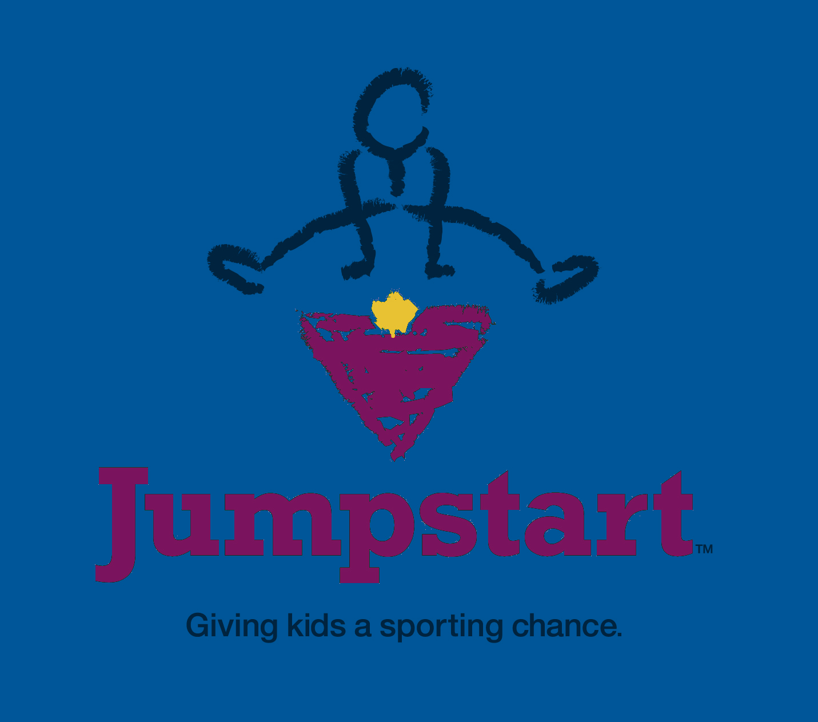

On behalf of Miramichi Boys & Girls Club & Jumpstart, we would like to thank you for your interest in our Jumpstart Program.
Miramichi Boys & Girls Club / Jumpstart program has two main funding allocation periods – one for the Spring/Summer season (deadline is May 30/14) and one for the Fall/Winter season (deadline is September 30/14).
The application form is used to identify children in financial need looking to participate in a specific sport or recreational activities. Our goal is to help those children that would not have otherwise been able to participate in a physical activity without the assistance of Jumpstart.
Listed below are the general funding guidelines:
Open to children aged 4 to 18 years old
Household income under $30,000
Two options to verify household income: choose one
- Attach proof of household income with the applicationOR
- Attach the Endorsement note in lieu of proof of income
Multiple children within the same family can apply
Children can apply for successive seasons in an activity
Funding is for individual children, not groups or teams
Funding must be a program that lasts a season
Funding is paid only to the organization
$300: a child may receive up to $300 per year from Jumpstart
Please send completed application form to:
Jumpstart Committee
Boys & Girls Club
115 Maher St. Miramichi, NB E1N 4B4
Email to: yvillage@nbnet.nb.caOr fax to 778-1855
JumpStart Application Form
Parent / Guardian Information
Parents or legal guardians must submit separate applications for each child.
Name of Parent / Guardian: __________________________________________________
Address: ________________________________________________________________
Community: __________________________________ Postal Code: __________________
Telephone: Daytime: ______________________ Cell Phone: ________________________
Email Address: ___________________________________________________________
Number of children in household: _____ Check one: ( ) One parent household ( ) Two parent household
Signature of Parent/Guardian: _____________________________ Date:________________________
Child / Youth Information
Name: __________________ Gender (Male __ Female __) Date of Birth (D/M/Y): ____/____/____
Has your child received previous JumpStart funding: Yes ____ No ____
Sport / Organization Information
Name of Sport/Activity: __________________________________________________________
Name of League/Organization: ____________________________________________________
Address: ______________________________________________________________________
Community: ___________________________________ Postal Code: _____________________
Name of contact: _____________________________Position: __________________________
Telephone: ______________________________ Cell: _________________________________
Email address: _________________________________________________________________
Activity start date: ___________________________Length of activity: ____________________

Funding Request
Total cost of program: $___________ Registration Request: $___________
Equipment Request: $_______________Type of Equipment: ____________________________
Total Request: $________________
Confirmation of Eligibility: please pick one of two options
☐Proof of household income attached with this application
☐Endorsement note that is attached; no proof of household income required
For Office Use Only:
Application received (d/m/y): _________ Approved: _____ Denied: ______ First Time Funding? Y /N ____
Funding Amount: $_______ Cheque Date (d/m/y): ____/____/____ Cheque #: _________

